Laboratory 2: Static Analysis, Metrics, Linting & AI Code Review
Amantle Dikoloti
Software Analysis and Testing • Student ID: 23017837

1. Objective and environment
This laboratory applied rule-based static analysis and complexity metrics to the Python Task Manager application, prioritised identified issues, corrected three Pylint findings, and compared automated linting with an AI-assisted review of two original code snippets.
Component | Tool / scope
Sample application | Task Manager — app/cli.py, app/storage.py, app/tasks.py
Runtime | Python 3.14.7
Linter | Pylint 4.1.3
Metrics | Radon 6.0.1
Test runner | Pytest 9.1.1
AI reviewer | ChatGPT

2. Static analysis and metrics
Pylint inspected the app package using the default generated .pylintrc configuration. The original report contained 12 messages and rated the code 8.33/10. After targeted corrections, Pylint rated it 8.93/10, an improvement of 0.60 points. The warnings W0102, R1732 and R1710 were no longer present in the subsequent report.
Metric | Before | After
Pylint rating | 8.33 / 10 | 8.93 / 10
Warnings targeted | W0102, R1732, R1710 | Not detected
Existing unit tests | 4 pass, 2 fail | 4 pass, 2 fail

2.1 Five highest-complexity functions
Cyclomatic complexity was reported by radon cc -s app. All analysed functions fell within Radon risk band A (low complexity); the fifth position below is tied with other functions scoring 2.
Function | File | Cyclomatic complexity | Band
complete_task | app/tasks.py | 3 | A
get_pending_tasks | app/tasks.py | 3 | A
find_task_by_title | app/tasks.py | 3 | A
remove_task | app/tasks.py | 3 | A
format_task_report | app/storage.py | 2 | A

2.2 Maintainability index
Source file | Radon MI | Band
app/cli.py | 72.27 | A
app/storage.py | 72.97 | A
app/tasks.py | 45.51 | A
app/__init__.py | 100.00 | A

The task module had the lowest maintainability index of the measured files. Low cyclomatic complexity did not eliminate functional defects: two pre-existing unit tests continued to fail.

3. Triage of ten Pylint findings
The following triage prioritises code correctness and maintainability. Severity and fix effort are analytical judgements, not Pylint-provided severity classifications.
Rule | Original location | Finding | Severity | Effort
W0102 | tasks.py:23 | Mutable default list argument | Medium | Low
R1732 | tasks.py:11 | File opened without context manager | Medium | Low
R1710 | tasks.py:62 | Inconsistent explicit return statements | Medium | Low
W1514 | tasks.py:11 | File opened without explicit encoding | Low | Low
W1514 | tasks.py:19 | File opened without explicit encoding | Low | Low
W0611 | cli.py:2 | Unused save_tasks import | Low | Low
W0611 | cli.py:2 | Unused add_task import | Low | Low
C0116 | cli.py:6 | main() missing function docstring | Low | Low
C0200 | tasks.py:71 | Loop could use enumerate | Low | Low
R1705 | tasks.py:79 | Unnecessary else after return | Low | Low

4. Three selected corrections and validation
Finding | Change implemented | Evidence / outcome
W0102 | Changed tags=[] to tags=None and allocated a new list inside add_task(). | Shared mutable default removed.
R1732 | Changed load_tasks() to use with open(..., encoding="utf-8"). | File closure guaranteed; encoding explicitly specified.
R1710 | Added return None when find_task_by_title() finds no match. | Explicit return behaviour consistent.

The version-controlled fixes.diff records the removed and added source lines. The three target rule codes were absent from lint_after.txt; the after-run score increased by 0.60 points. The project’s pre-existing pytest suite collected all six tests and yielded four passes, two failures. The two unresolved failures concern the first pending task being skipped and division by zero on an empty list; neither was part of the three selected Pylint fixes.

5. AI code review compared with rule-based linting

5.1 Original snippet A: task creation
def add_task(tasks, title, priority=1, tags=[]):
Pylint flagged W0102 because a mutable list is used as a default parameter. The AI review identified the same issue and also observed that IDs derived from len(tasks) + 1 can be duplicated following deletion; it also identified a lack of input validation for the title and priority. Those additional points are manual-review hypotheses, not findings reported by the linter.

5.2 Original snippet B: task loading
f = open(TASKS_FILE, "r")
data = json.load(f)
return data
Pylint reported R1732 for the absence of a context manager and W1514 for missing encoding. The AI review agreed and also observed that a malformed JSON file would raise an unhandled decoding exception. No corrupted-file test was run in this laboratory.

5.3 Comparison summary
Issue | Pylint | AI review
Mutable default tags list | Detected | Detected
Missing file context manager | Detected | Detected
Missing explicit encoding | Detected | Detected
Duplicate IDs after deletion | Not flagged | Identified
Malformed JSON handling | Not flagged | Identified
Task input validation | Not flagged | Identified

6. Reflection and discussion
The linter was useful for consistent, repeatable identification of coding patterns such as mutable defaults, file-management practices and return-style problems. It did not directly identify the task-ID design risk or the failure to handle malformed task data, which required reasoning about program behaviour. AI review helped generate those additional questions, but they would still need targeted tests and specification checks before being treated as confirmed defects. The tests also demonstrated that a better lint score does not necessarily mean that the application’s known functional defects have been resolved. I observed that Pylint was effective at identifying coding problems such as mutable default arguments and improper file handling. However, ChatGPT also identified possible design and logic issues, including duplicate task IDs and missing error handling. This showed me that AI code review can complement static analysis, although its suggestions still need verification.

7. Evidence captured from the lab session
The supporting terminal captures below show representative original findings, complexity results, improved score and the generated diff. Full machine-generated text reports remain in the local lab-2-23017837 folder.
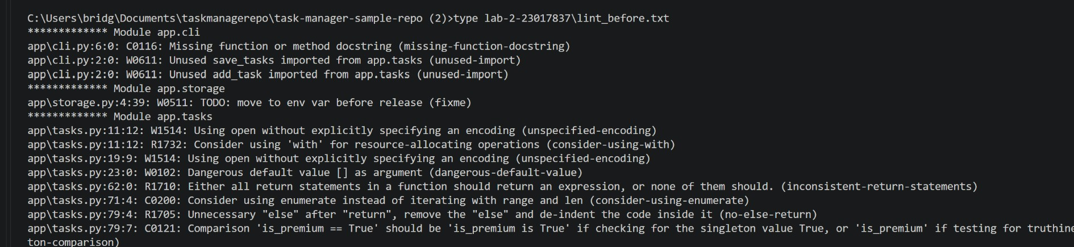
Figure 1. Pylint original findings (terminal output)
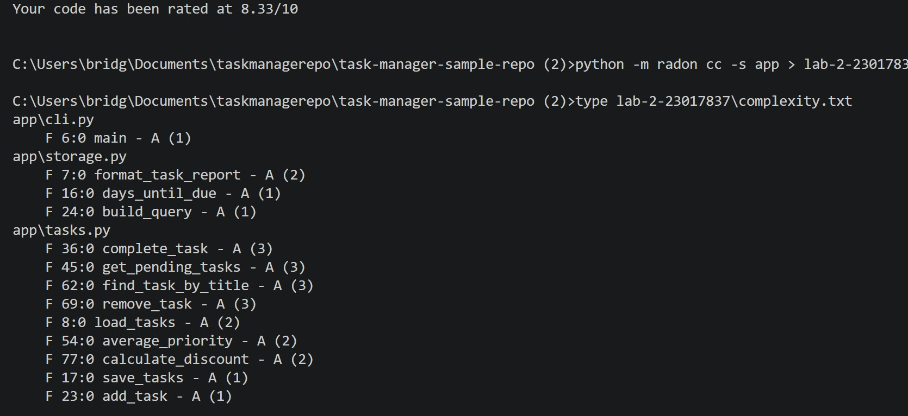
Figure 2. Radon cyclomatic-complexity measurement
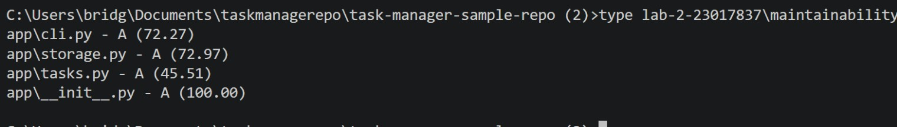
Figure 3. Radon maintainability-index measurement
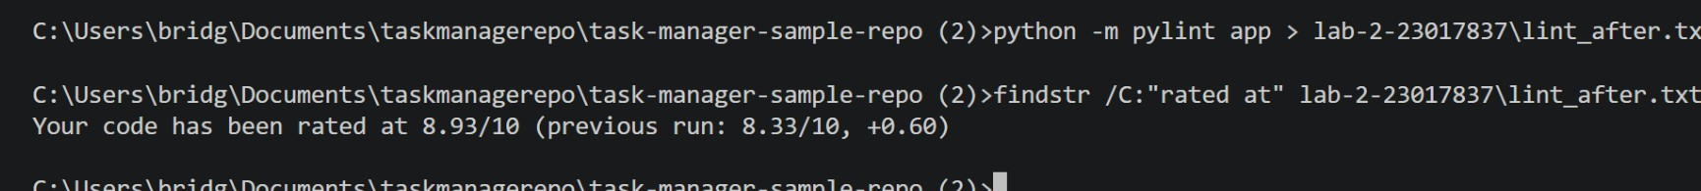
Figure 4. Post-correction Pylint score (8.93/10, +0.60)
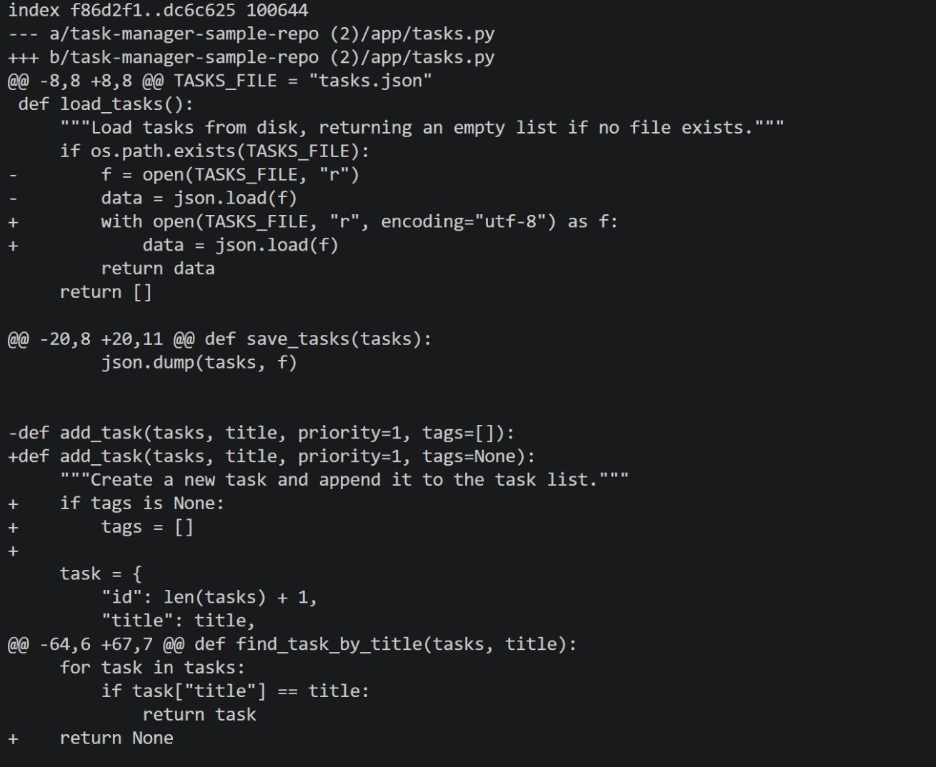
Figure 5. Git diff excerpt documenting all three code changes

